**1. Database Creation**

-- Create the database

CREATE DATABASE academic_management;

USE academic_management;

-- Create StudentInfo table

CREATE TABLE StudentInfo (

STU_ID VARCHAR(10) PRIMARY KEY,

STU_NAME VARCHAR(50) NOT NULL,

DOB DATE NOT NULL,

PHONE_NO VARCHAR(15),

EMAIL_ID VARCHAR(50) UNIQUE,

ADDRESS TEXT

);

-- Create CoursesInfo table

CREATE TABLE CoursesInfo (

COURSE_ID VARCHAR(10) PRIMARY KEY,

COURSE_NAME VARCHAR(100) NOT NULL,

COURSE_INSTRUCTOR_NAME VARCHAR(50) NOT NULL

);

-- Create EnrollmentInfo table

CREATE TABLE EnrollmentInfo (

ENROLLMENT_ID VARCHAR(10) PRIMARY KEY,

STU_ID VARCHAR(10),

COURSE_ID VARCHAR(10),

ENROLL_STATUS ENUM('Enrolled', 'Not Enrolled') DEFAULT 'Not Enrolled',

FOREIGN KEY (STU_ID) REFERENCES StudentInfo(STU_ID),

FOREIGN KEY (COURSE_ID) REFERENCES CoursesInfo(COURSE_ID)

);

-- Add indexes for better performance

CREATE INDEX idx_student_name ON StudentInfo(STU_NAME);

CREATE INDEX idx_course_name ON CoursesInfo(COURSE_NAME);

CREATE INDEX idx_enrollment_status ON EnrollmentInfo(ENROLL_STATUS);

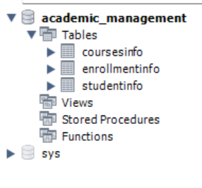

**2. Data Creation:**

INSERT INTO StudentInfo (STU_ID, STU_NAME, DOB, PHONE_NO, EMAIL_ID, ADDRESS) VALUES

('S1001', 'Karthikeyan Subramanian', '2000-05-15', '+91-9876543201', 'karthik.s@email.com', '45, Gandhi Street, Adyar, Chennai - 600020, Tamil Nadu'),

('S1002', 'Lakshmi Priya Ramanathan', '2001-07-22', '+91-9876543202', 'lakshmi.r@email.com', '12/5, Kamarajar Salai, T.Nagar, Chennai - 600017, Tamil Nadu'),

('S1003', 'Muthu Krishnan', '2000-03-30', '+91-9876543203', 'muthuk@email.com', '78, East Coast Road, Besant Nagar, Chennai - 600090, Tamil Nadu'),

('S1004', 'Deepa Venkatesh', '2001-11-12', '+91-9876543204', 'deepa.v@email.com', '23, Raja Street, Mylapore, Chennai - 600004, Tamil Nadu'),

('S1005', 'Arun Prasad', '2000-09-25', '+91-9876543205', 'arun.p@email.com', '156, Anna Nagar West, Chennai - 600040, Tamil Nadu'),

('S1006', 'Meenakshi Sundaram', '2001-04-18', '+91-9876543206', 'meena.s@email.com', '89, Pondy Bazaar, T.Nagar, Chennai - 600017, Tamil Nadu'),

('S1007', 'Senthil Kumar Rajan', '2000-08-09', '+91-9876543207', 'senthil.r@email.com', '34, West Mambalam, Chennai - 600033, Tamil Nadu'),

('S1008', 'Anandhi Thirumalai', '2001-01-30', '+91-9876543208', 'anandhi.t@email.com', '67, Ashok Nagar, Chennai - 600083, Tamil Nadu');

-- Insert data into CoursesInfo table

INSERT INTO CoursesInfo (COURSE_ID, COURSE_NAME, COURSE_INSTRUCTOR_NAME) VALUES

('CS101', 'Introduction to Computer Science', 'Dr. Rajagopalan Venkatesan'),

('MT201', 'Advanced Mathematics', 'Prof. Saraswathi Krishnamoorthy'),

('PH301', 'Physics Fundamentals', 'Dr. Shanmugam Palaniappan'),

('EN401', 'English Literature', 'Prof. Padmavathi Ranganathan'),

('DB501', 'Database Management', 'Dr. Balakrishnan Narayanan'),

('TM101', 'Tamil Literature', 'Prof. Tamilselvan Murugesh'),

('CH201', 'Chemistry Basics', 'Dr. Vasudevan Sundaram');

-- Insert data into EnrollmentInfo table

INSERT INTO EnrollmentInfo (ENROLLMENT_ID, STU_ID, COURSE_ID, ENROLL_STATUS) VALUES

('E10001', 'S1001', 'CS101', 'Enrolled'),

('E10002', 'S1001', 'MT201', 'Enrolled'),

('E10003', 'S1002', 'PH301', 'Enrolled'),

('E10004004', 'S1003', 'CS101', 'Enrolled'),

('E10005', 'S1004', 'EN401', 'Not Enrolled'),

('E10006', 'S1005', 'DB501', 'Enrolled'),

('E10007', 'S1002', 'TM101', 'Enrolled'),

('E10008', 'S1006', 'MT201', 'Enrolled'),

('E10009', 'S1007', 'DB501', 'Enrolled'),

('E10010', 'S1008', 'CH201', 'Enrolled'),

('E10011', 'S1003', 'TM101', 'Not Enrolled'),

('E10012', 'S1004', 'CH201', 'Enrolled');

**3) Retrieve the Student Information**

SELECT

s.STU_ID as StudentID,

s.STU_NAME as StudentName,

s.PHONE_NO as PhoneNo,

s.EMAIL_ID as EmailID,

GROUP_CONCAT(

CONCAT(c.COURSE_NAME, ' (', e.ENROLL_STATUS, ')')

ORDER BY c.COURSE_NAME

SEPARATOR '; '

) as Course_Details

FROM

StudentInfo s

LEFT JOIN EnrollmentInfo e ON s.STU_ID = e.STU_ID

LEFT JOIN CoursesInfo c ON e.COURSE_ID = c.COURSE_ID

GROUP BY

s.STU_ID, s.STU_NAME, s.PHONE_NO, s.EMAIL_ID

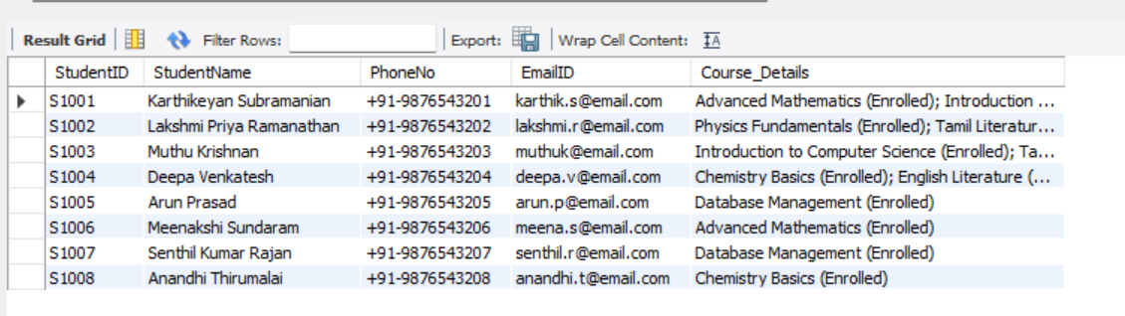

**Write a query to retrieve a list of courses in which a specific student is enrolled**

SELECT

s.STU_NAME,

s.PHONE_NO,

s.EMAIL_ID,

s.ADDRESS,

c.COURSE_NAME,

e.ENROLL_STATUS

FROM

StudentInfo s

LEFT JOIN EnrollmentInfo e ON s.STU_ID = e.STU_ID

LEFT JOIN CoursesInfo c ON e.COURSE_ID = c.COURSE_ID

WHERE

s.STU_NAME LIKE '%Karthik%'

;

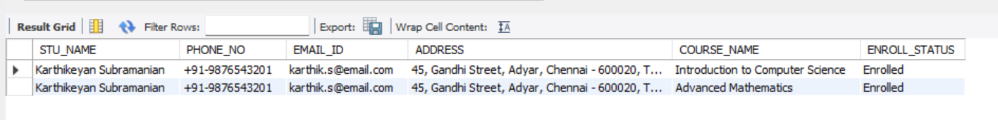

**Write a query to retrieve course information, including course name, instructor information.**

SELECT

COURSE_ID,

COURSE_NAME,

COURSE_INSTRUCTOR_NAME

FROM

CoursesInfo

ORDER BY

COURSE_NAME;

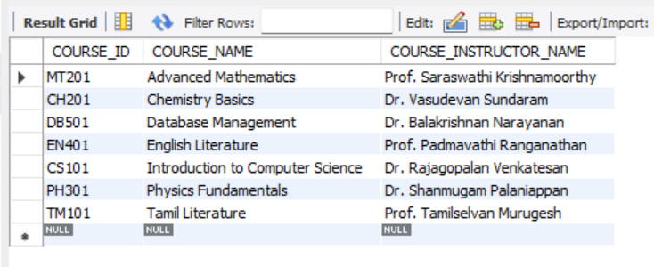

**Write a query to retrieve course information for a specific course.**

SELECT

COURSE_ID,

COURSE_NAME,

COURSE_INSTRUCTOR_NAME

FROM

CoursesInfo

WHERE

COURSE_NAME = 'Chemistry Basics';

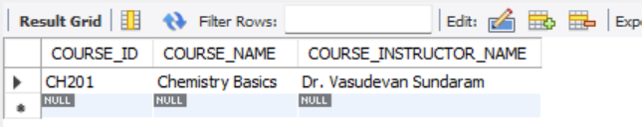

**Write a query to retrieve course information for multiple courses.**

SELECT

COURSE_ID,

COURSE_NAME,

COURSE_INSTRUCTOR_NAME

FROM

CoursesInfo

WHERE

COURSE_NAME in ('Chemistry Basics', 'Physics Fundamentals');

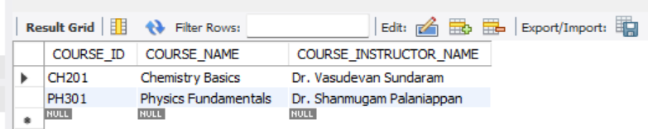

**Write a query to retrieve the number of students enrolled in each course.**

SELECT

COURSE_NAME,

COUNT(ei.STU_ID) as count_students

FROM

CoursesInfo as ci

INNER JOIN EnrollmentInfo as ei ON ci.COURSE_ID = ei.COURSE_ID

WHERE

ei.ENROLL_STATUS = 'Enrolled'

GROUP BY 1

;

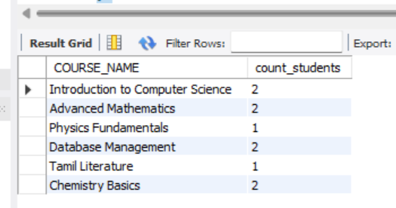

**Write a query to retrieve the list of students enrolled in a specific course. please answer with one query.**

SELECT

c.COURSE_NAME as 'Course',

c.COURSE_INSTRUCTOR_NAME as 'Instructor',

s.STU_ID as 'Student ID',

s.STU_NAME as 'Student Name',

s.PHONE_NO as 'Contact Number',

s.EMAIL_ID as 'Email',

e.ENROLL_STATUS as 'Status',

s.ADDRESS as 'Address'

FROM

CoursesInfo c

JOIN EnrollmentInfo e ON c.COURSE_ID = e.COURSE_ID

JOIN StudentInfo s ON e.STU_ID = s.STU_ID

WHERE

c.COURSE_ID = 'CS101' -- Change course ID as needed

AND e.ENROLL_STATUS = 'Enrolled'

ORDER BY

s.STU_NAME;

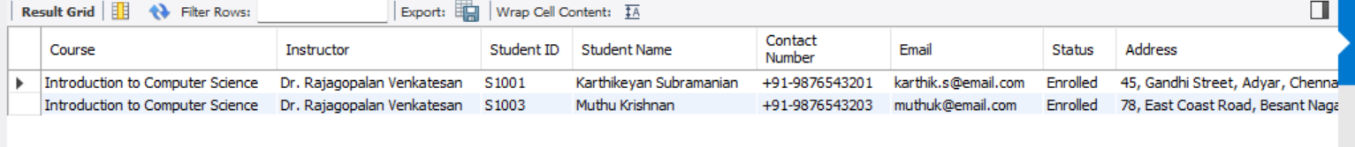

**Write a query to retrieve the count of enrolled students for each instructor.**

SELECT

c.COURSE_INSTRUCTOR_NAME,

COUNT(DISTINCT CASE WHEN e.ENROLL_STATUS = 'Enrolled' THEN s.STU_ID END) as Enrolled_Student_Count

FROM

CoursesInfo c

LEFT JOIN EnrollmentInfo e ON c.COURSE_ID = e.COURSE_ID

LEFT JOIN StudentInfo s ON e.STU_ID = s.STU_ID

GROUP BY

c.COURSE_INSTRUCTOR_NAME

ORDER BY

Enrolled_Student_Count DESC;

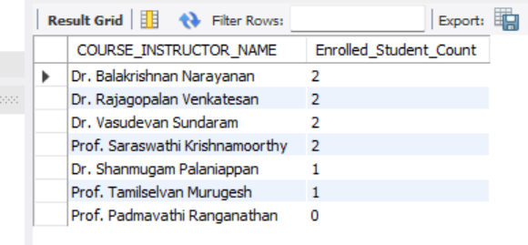

**Write a query to retrieve the list of students who are enrolled in multiple courses.**

SELECT

s.STU_ID,

s.STU_NAME,

COUNT(DISTINCT e.COURSE_ID) as Course_Count

FROM

StudentInfo s

JOIN EnrollmentInfo e ON s.STU_ID = e.STU_ID

JOIN CoursesInfo c ON e.COURSE_ID = c.COURSE_ID

WHERE

e.ENROLL_STATUS = 'Enrolled'

GROUP BY

1, 2

HAVING

COUNT(DISTINCT e.COURSE_ID) > 1

;

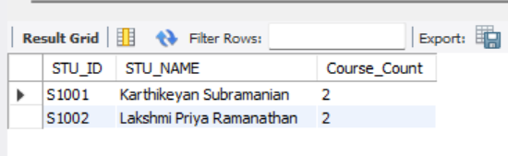

**Write a query to retrieve the courses that have the highest number of enrolled**

**students(arranging from highest to lowest).**

SELECT

c.COURSE_ID,

c.COURSE_NAME,

c.COURSE_INSTRUCTOR_NAME,

COUNT(CASE WHEN e.ENROLL_STATUS = 'Enrolled' THEN e.STU_ID END) as Enrolled_Students

FROM

CoursesInfo c

LEFT JOIN EnrollmentInfo e ON c.COURSE_ID = e.COURSE_ID

LEFT JOIN StudentInfo s ON e.STU_ID = s.STU_ID

GROUP BY

c.COURSE_ID, c.COURSE_NAME, c.COURSE_INSTRUCTOR_NAME

ORDER BY

Enrolled_Students DESC;

